AS-EACS-2025-00748
Title:
Cost-effectiveness of lenacapavir versus tenofovir disoproxil fumarate plus emtricitabine for pre-exposure prophylaxis to prevent HIV-1 transmission in gay, bisexual and other men who have sex in a European country
Preferred presentation type:
Oral presentation
Authors:
P. Wikman-Jorgensen ^{1, 2}, C. Iniesta ^{3, 4}, M. Ruiz-Algueró ⁸, F. Pulido ⁵, J.A. Perez-Molina ^{4, 6}, J. Llenas-García ^{2, 4, 8}
¹Hospital General Universitario de Elda-FISABIO, Infectious Diseases-Internal Medicine, Elda, Spain, ²Universidad Miguel Hernández, Clinical Medicine, Elche, Spain, ³Spanish Interdisciplinary AIDS Society (SEISIDA)., Madrid, Spain, , CIBER de Enfermedades Infecciosas (CIBERINFEC), ⁴Instituto de Salud Carlos III, Madrid, Spain, ⁵University of British Columbia, Faculty of Medicine,, Vancouver, Canada, ⁶Institute for Healthcare Research Hospital 12 de Octubre (imas12), Universidad Complutense de Madrid, HIV Unit, Madrid, Spain, ⁷University Hospital Ramon y Cajal, 6. Referral Centre for Tropical Diseases. Infectious Diseases Department., Madrid, Spain, ⁸Hospital Vega Baja-FISABIO, Infectious Diseases-Internal Medicine, Orihuela, Spain
Con todas las filiaciones que hay yo te apunto las mías aparte para aclararte:
⁷ Referral Centre for Tropical Diseases. Infectious Diseases Department, University Hospital Ramon y Cajal, Madrid, Spain
CIBER de Enfermedades Infecciosas (CIBERINFEC), ⁴Instituto de Salud Carlos III, Madrid, Spain

Purpose: *
Lenacapavir (LEN) has proven to be superior to, tenofovir disoproxil fumarate plus emtricitabine (TDF/FTC), as pre-exposure prophylaxis (PrEP) for key populations at high risk of HIV acquisition. This study aims to compare the cost-effectiveness of currently approved PrEP in Spain, with daily TDF/FTC, in gay, bisexual and other men who have sex with men (GBMSM) versus the newer alternative with subcutaneous LEN every 6 months.
Alternativa un poco más corta: The study assessed which PrEP strategy was more cost-effective for gay, bisexual and other men who have sex with men (GBMSM) in Spain: daily oral TDF/FTC or subcutaneous LEN administered every six months.

Method: *
We fitted a dynamic compartmentalised Markov model that represents the dynamics of HIV-1 transmission in GBMSM in Spain. The model was calibrated to replicate the epidemiological data from 2019 to 2023. We used the perspective of the national health system and applied a 20-year time horizon. Quality-adjusted life years (QALY) were the health outcome variable, and the cost was accounted for in 2023 Euros (€). Our outcome variable was the incremental cost-effectiveness ratio (ICER). We used the 2023 gross domestic product per capita of Spain (€31,339) as the willingness-to-pay (WTP) threshold.
Results: *
In the TDF/FTC arm the simulation yielded 8,546,030 QALYs at a cost of €8,457,028,025 for the next 20 years, with an average cost-effectiveness ratio of €989.58 per QALY. If LEN were used instead of TDF/FTC, it would cost €47,062,063,906 (an increase of €38,605,035,881) producing a total of 9,030,933 QALYs (i.e. an increase of 484,903.7 QALYs), yielding an ICER of 79,613.82 €/QALYs. Adherence and number of GBMSM living with HIV were the main variables affecting the ICER in a deterministic sensitivity analysis. However, it did not come close to WTP. A probabilistic sensitivity analysis was also undertaken where the cost was iterated down to € 4,320 per six-month dose yielding a probability of cost-effectiveness of 93.6%.
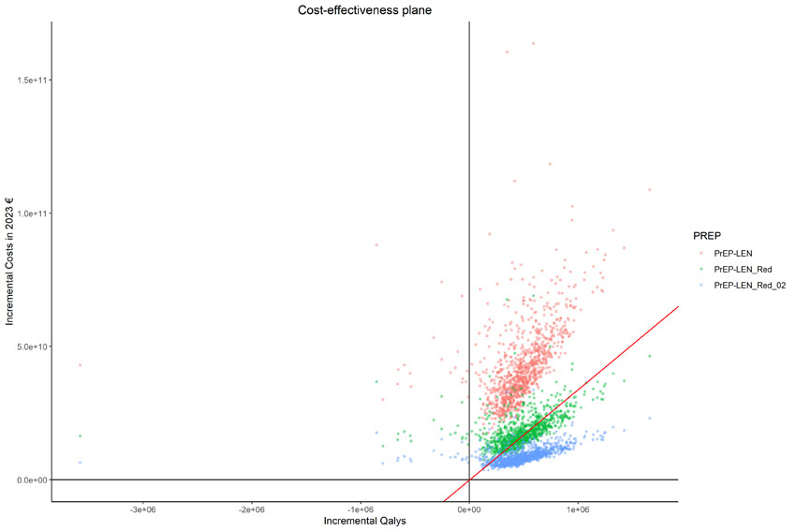

Alt text: Scatter plot titled "Cost-effectiveness plane" showing incremental costs in 2023 euros on the y-axis and incremental QALYs on the x-axis for three PrEP strategies: PrEP-LEN (red), PrEP-LEN_Red (green), and PrEP-LEN_Red_02 (blue), representing different LEN prices.. Each point represents a simulation result. A red diagonal line indicates a willingness-to-pay threshold. Most points lie in the upper-right quadrant, suggesting increased cost and effectiveness, with PrEP-LEN_Red_02 generally appearing to be more cost-effective than the others.
Si es posible llamaría a cada categoría de otra manera para que se entendiera mejor. Si son precios algo como LEN_Scenario01, LEN_Scenario02 y LEN_Scenario03. Añadiría en el gráfico en texto la áreas de coste efectividad y las que no lo son.

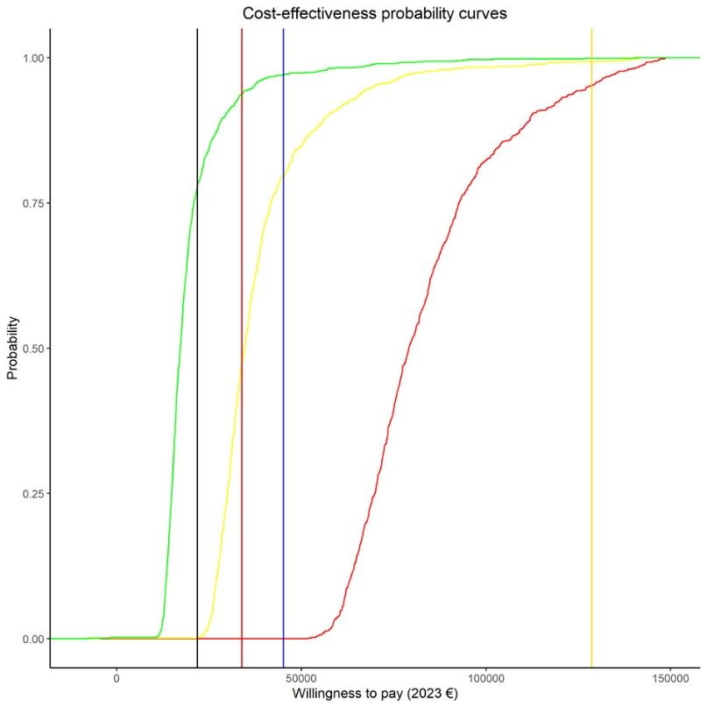

Alt text: Line graph titled "Cost-effectiveness probability curves" showing the probability that a PrEP strategy is cost-effective across a range of willingness-to-pay (WTP) thresholds in 2023 euros. Three sigmoidal curves represent different drug costs: red (€21,088.5), yellow (€8,880), and green (€4,320). Four vertical lines mark GDP per capita values: black (Croatia), red (Spain), blue (Euro Zone), and yellow (Luxembourg). The green curve reaches high probability at the lowest WTP, followed by the yellow and then the red, indicating increasing cost-effectiveness with lower drug prices

Conclusions: *
Twice-yearly subcutaneous LEN could be cost-effective as Prep for GBMSM in Spain at a threshold of €4,320 per six-month dose.
Abstract word count:
Words: 300 of 300
Tables: 0 of 3
Table rows: 0 of 30
Images: 2 of 2

